**COINsolidation**

**Token distribution, custody and auditing.**

audit@coinsolidation.org

[www.coinsolidation.org /](http://www.coinsolidation.org/) [www.coinsolidation.io](http://www.coinsolidation.io/)

**Summary**: The following manifest is issued for interested investors and the general public on the distribution, custody, distribution and auditable policies that will govern the COINsolidation token. The COINsolidation token is based on Ethereum technology, with a total amount of 40,000,000,000,000 ERC20 crypto-assets tokens. The distribution applied for the regulation is carried out in 9 items (concepts) and the main one referring to the placing on the market in its different modalities will be carried out in periods of 2 years, the custody will be applied for each period and for the amount of tokens sold in the respective period until having a maximum of the amount released, only in the concept of sale to the public item "TOKEN SALE" described in the ICO distribution table. The audit will be performed on the financial statements and on each of the 9 items (concepts) where the total amount of tokens will be distributed, this audit will be performed at least once a year. All results, notices and announcements will be published on social media, as well as on the websites [www.coinsolidation.org](http://www.coinsolidation.org) and its backend [www.coinsolidation.io.](http://www.coinsolidation.io)



Asset type: TOKEN ERC20 (Ethereum).

Name: COINsolidation

Symbol: CUAG - (Consolidated Universal Address Genesis).

Total tokens created: 40,000,000,000,000.00

Number of decimals: 18

Country of Launch: Estonia

Official website: [www.COINsolidation.org](http://www.Coinsolidation.org)

Company: COINsolidation International or a leading company in Estonia.

Launch date: 30, April 2021

Addressing algorithm: Consolidated Universal Address (CUA).

Security employed: PQC (Post-Quantum Cryptography) based on quantum computing.

Technological proposal: Extensions for Blockly systems for the use of cryptocurrencies and implementation of quantum security.

# COINsolidation Token (CUAG) - ICO DISTRIBUTION PLAN.

The ICO is divided into three stages:





|  |  |
| --- | --- |
| 0x9d08c0ac0f2fdf078c883db6fa617b15776e4b41 | **COINsolidation TOKEN** |
| 0xbbF57DE98c59B4C304C9d15BC5FAb01304aeCD97 | **ICO ADDRESS** |
| 0xa646c054394f85257E18D56Cf5c6b5E603447470 | **COINSOLIDATION OPERATION ADDRESS** |

**DISTRIBUTION BASED ON PERIODS EVERY 2 YEARS.**

Introduction of item "Token Sale" with a total amount of 28,000,000,000,000 and a total asset percentage of 70%, complies with the following distribution, 50% (14,000,000,000,000) will go on sale, the other 50% (14,000,000,000,000) will go into escrow for a period of 2021-2089.

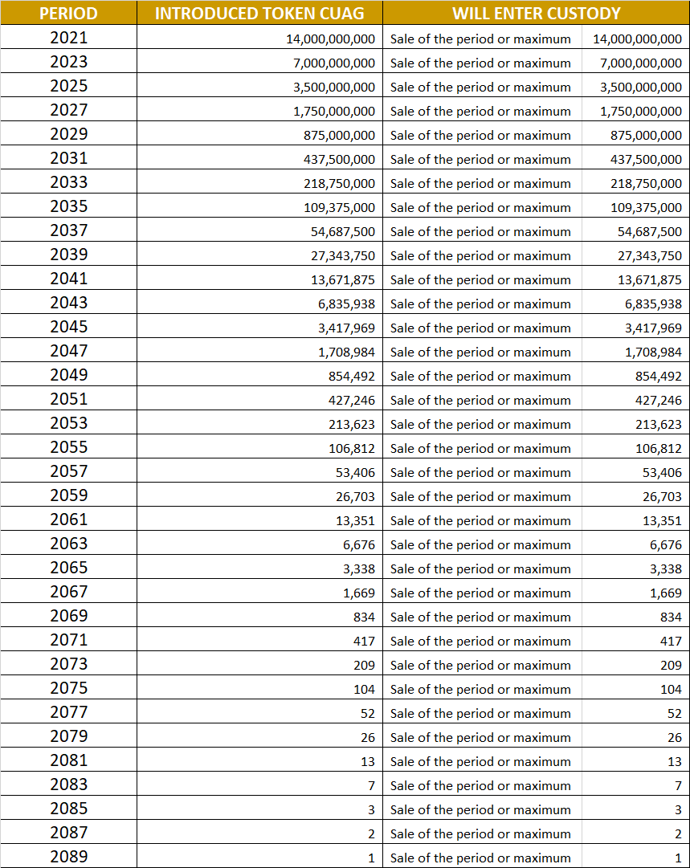

**INITIAL SALES DISTRIBUTION ICO.**



**AUDIT**

THE AUDIT OF THE TOKEN SALE WILL BE CARRIED OUT EVERY YEAR WITH 11 MONTHS, ONE MONTH BEFORE THE NEXT BLOCK OF TOKENS IS RELEASED FOR SALE, WHICH ARE DESIGNATED AS CATEGORY "A".



In category "A" - "TOKEN SALE" 50% (14,000,000,000,000) will go on sale, the other 50% (14,000,000,000,000) will go into escrow for a total of 28,000,000,000,000 tokens for sales.

**DISTRIBUTION AUDIT ON THE REMAINING ITEMS OTHER THAN "TOKEN SALES" THIS WILL BE DONE ON AN ANNUAL BASIS BASED ON THE FISCAL YEAR JANUARY-DECEMBER. CONSIDERING DIVIDENDS EVERY 4 MONTHS (Q1, Q2 Q3 AND Q4). DENOMINATED AS CATEGORY "B".**

All items other than token sales will be tax audited and should be reflected in the annual report. The items that will be tax audited will be:



The audit will be carried out on the basis of the "Operations" direction set out in the "**ICON DISTRIBUTION PLAN**" distribution table.

The audit of the item "TEAM AND DEVELOPMENT" will be based on the following concepts:

* Results (measurable time scopes and development scopes) - Presentation of annual audit.
* Training
* Investment for development inputs (computer equipment and recurrent workplace costs).
* Development tools (Licensing and support).
* Conferences and events.
* Salaries (fixed, variable and temporary).

The audit of the item "ADVISORS" will be based on the following concepts - Annual audit submission.

* Results (measurable benefits achieved in Q1, Q2, Q3 and Q4) - Annual audit submission.
* Consultancy
* Consultancy
* Conferences
* Evangelisation of the COINsolidation ecosystem.
* Trafficking or temporary bonds.

The audit of the item "PARTNERS" will be based on the following concepts - Annual audit submission.

* Technological cooperation for the improvement and/or growth of the COINsolidation ecosystem.
* Cooperation on the use of patents.

The audit of the item "EXCHANGES MARKET" will be based on the following concepts:

* Results (measurable benefits achieved in Q1, Q2, Q3 and Q4) - Annual audit submission.
* Review of liquidity levels in each selected Exchange.
* Fully Diluted Market Cap results in emerging markets.
* Review of integration in new Exchanges.

The audit of the item "MARKETING" will be based on the following concepts:

* Results (measurable benefits achieved in Q1, Q2, Q3 and Q4) - Annual audit submission.
* Social media - measuring user reach.
* Monthly, bi-monthly, bi-annual, semi-annual and annual events Results (measurable benefits achieved in Q1, Q2, Q3 and Q4).
* Financial media (news, blogs, newspapers, etc.).

The audit of the item "COINSOLIDATION FOUNDATION" will be based on the following concepts - Annual audit submission.

* Development of EXOCRYPTO project - Submission of annual audit.
* Scholarships aimed at training professionals in the area of cryptocurrencies in different sectors (development, legal, finance, investment and business integration).
* Development and growth of OOwiki.org

The audit of the item "BLOCKLY DEVELOPER COMMUNITIES" will be based on the following concepts - Annual audit submission.

* Developments with Blockly technology referenced to the cryptocurrency market - Presentation of annual audit.
* Free training courses for new developers
* Conferences

The audit of the item "OPENQBIT DEVELOPMENT AND RESEARCH OF QUANTUM COMPUTING" will be based on the following concepts - Submission of annual audit.

* Research and development of the creation of the first processor with low-cost quantum technology that can be made available to the majority of the world's population - Annual audit submission.
* PQC (Post-Quantum Cryptography) security research and development.
* Quantum consensus improvements.
* Research, development and improvement of MINI BlocklyChain.

**CODE AUDITING**

We will audit and release code of programs based on the algorithms developed by COINsolidation, the code audit will be performed by COINsolidation before the release of each version, the code audits will be performed on the codes of the mobile applications developed by COINsolidation, because we do not create any blockchain or "Fork" but the COINsolidation token is created to be used in the Ethereum blockchain we will only audit our developments (Android applications) based on the following algorithms or additional projects that we will be releasing.

Released code from the following algorithms:

CUA - Consolidated Universal Address

DAC - Dual Address Consolidated

HAC . - Hybrid Address Consolidated.

The oneCkey (one Consolidated private Key) algorithm code will be audited and reported annually at the end of each year. No code will be released for security reasons. Only code auditing will be performed.

To review code see link: [www.coinsolidation.org](http://www.coinsolidation.org)

For more information, doubts or questions: [hello@coinsolidation.org](mailto:hello@coinsolidation.org) or [www.coinsolidation.org](http://www.coinsolidation.org)